Digital Forensics in Industrial Control Systems (ICS)
Water-tank laboratory on OpenPLC v3 — Stuxnet-style attack and investigation
Achraf YASMINE— VILNIUS TECH, Cyber Forensics
Lab report

1. Introduction and objective
This laboratory reproduces, end to end and reproducibly, an industrial cybersecurity incident and its forensic investigation. An OpenPLC v3 programmable logic controller (PLC) drives a simulated water tank; an attacker on the industrial network sabotages it, after which the investigation is carried out: evidence acquisition, analysis, and the reconstruction of a single incident timeline.
Scenario (inspired by Stuxnet):
- Reconnaissance — the attacker maps the network and enumerates the PLC's Modbus registers.
- Process manipulation — unauthorized Modbus writes (force pump, raise setpoint) from a non-HMI host.
- Logic tampering — upload of a tampered program that disables the safety and spoofs the level shown to the operator, while the tank actually overflows.
The core of the demonstration is the gap between "what the operator saw" and "what really happened", reconstructed from the evidence.

2. Laboratory architecture
Four Docker containers on an isolated network ics_net (172.28.0.0/24), all on UTC:
Service | IP | Role
plc | 172.28.0.10 | OpenPLC v3 PLC. Modbus/TCP (502) + web interface (8080).
hmi | 172.28.0.20 | Supervision + historian: polls the PLC every second, logs to CSV (UTC).
attacker | 172.28.0.66 | Attacker workstation (nmap, pymodbus, curl). Idle by default.
sniffer | (plc netns) | tcpdump probe: captures all PLC traffic into a .pcap.

Modbus/TCP has no authentication or encryption: any host on the network can read AND write the process variables. This is the flaw the attack exploits.

3. The process and the register map
The tank (level 0–1000) is filled by a pump and emptied by a drain valve. The physics is simulated inside the PLC scan cycle. Hysteresis: the pump starts below the LOW setpoint (200) and stops above the HIGH setpoint (800). A safety cutoff stops the pump above 950; an overflow bit latches at 1000.
IEC variable | Modbus object | Addr. | Meaning
%QX0.0 | Coil | 0 | Pump running
%QX0.2 | Coil | 2 | High-level alarm (HMI view)
%QX0.3 | Coil | 3 | Overflow latched (HMI view)
%QW0 | Holding reg | 0 | Level shown to the HMI
%MW0 | Holding reg | 1024 | HIGH setpoint (written by engineer/attacker)
%MW2 | Holding reg | 1026 | Manual pump command 0/1
%MW10 | Holding reg | 1034 | TRUE level (hidden, written by the PLC)

Key point: the hidden register %MW10 (Modbus address 1034) holds the TRUE level. In normal operation the displayed level %QW0 equals it; under the tampered program, %QW0 is spoofed while %MW10 tells the truth.

4. Step 1 — Setup and verification
The 00_setup.sh script builds the OpenPLC image (cloned from the official repository), starts the 4 containers (network capture begins immediately), then configures the PLC over HTTP: login (openplc/openplc), upload of the legitimate program, compilation, start. Finally it verifies Modbus.
Fig. 1 — Modbus verification after setup: level_hmi = true_level = 251 (the PLC tells the truth).
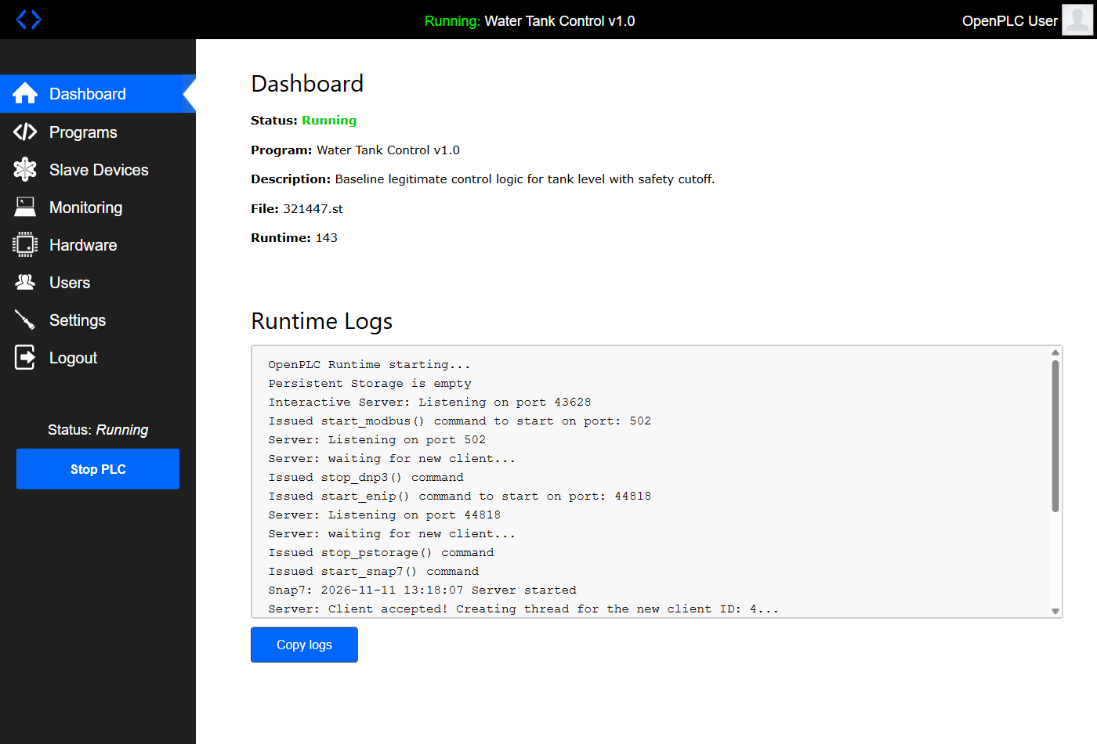
Fig. 2 — OpenPLC dashboard: program "Water Tank Control v1.0", status Running.

5. Step 2 — Baseline (normal operation)
The baseline is the "all is well" reference snapshot. The system runs normally, then a clean state is frozen (program, SQLite database, configs) and SHA-256 hashes are computed — the foundation of evidence integrity.
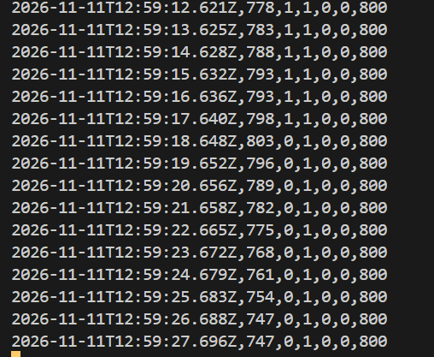
Fig. 3 — HMI historian: level oscillating ~200–800, alarm = 0 (columns: time, level, pump, drain, alarm, overflow, setpoint).
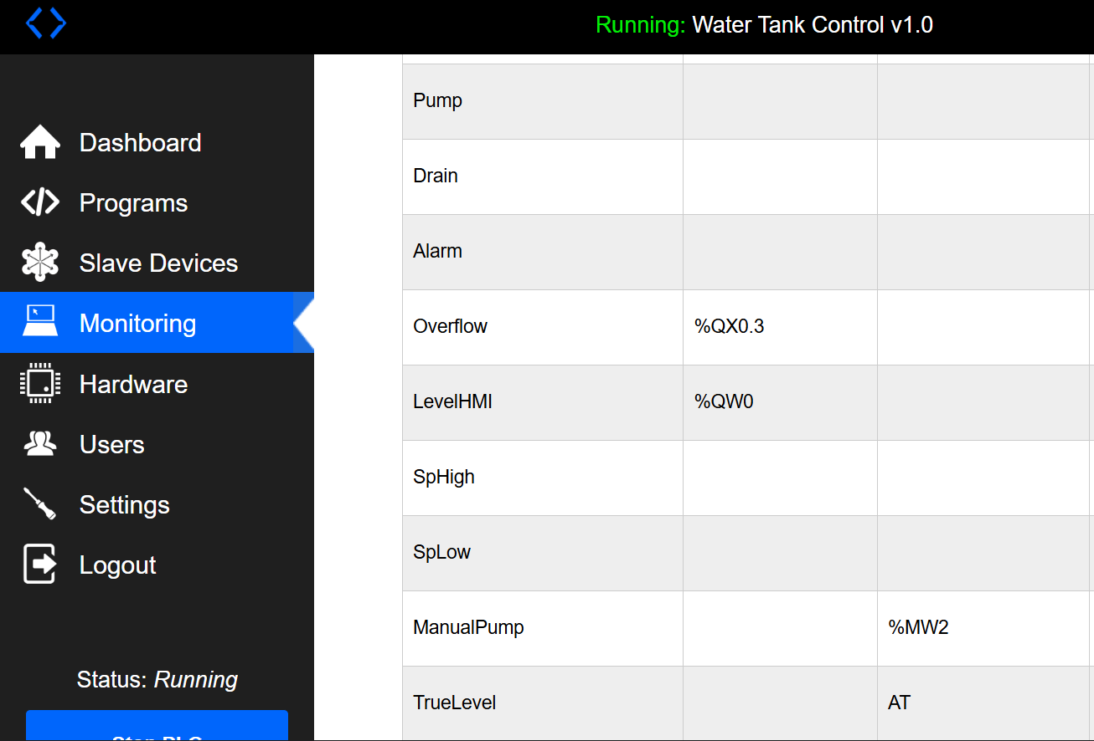
Fig. 4 — OpenPLC Monitoring page: the process variables and their addresses (%QW0, %MW2, %QX0.3…).
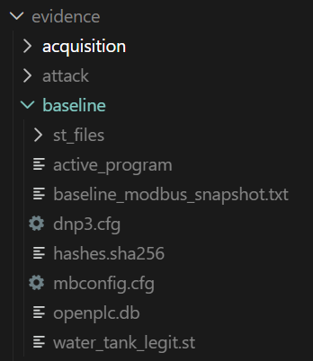
Fig. 5 — Frozen baseline evidence: openplc.db, st_files, hashes.sha256…

6. Step 3 — The three-phase attack
All actions originate from the attacker container (172.28.0.66): this is what makes them identifiable in the pcap (the legitimate HMI is 172.28.0.20).

6.1 Phase 1 — Reconnaissance
nmap discovers the network hosts (ARP sweep), then probes the Modbus service on port 502. Finally, pymodbus enumerates every register — including the hidden true level %MW10: the attacker has full, unauthenticated visibility of the process.
evidence/attack/recon_nmap_hostdiscovery.txt
Starting Nmap 7.95 ( https://nmap.org ) at 2026-11-11 13:20 UTC
Nmap scan report for 172.28.0.1
Host is up (0.00018s latency).
MAC Address: 1A:4E:42:98:21:1D (Unknown)
Nmap scan report for ics-plc.ics_net (172.28.0.10)
Host is up (0.0000040s latency).
MAC Address: 22:EB:C3:AF:C3:A2 (Unknown)
Nmap scan report for ics-hmi.ics_net (172.28.0.20)
Host is up (0.000052s latency).
MAC Address: E2:F7:C3:88:71:BF (Unknown)
Nmap scan report for attacker (172.28.0.66)
Host is up.

evidence/attack/recon_modbus_enumeration.txt — the true level is already readable
Modbus enumeration of PLC 172.28.0.10:502
pump = 0
drain = 1
alarm = 0
overflow = 0
level_hmi = 380
sp_high = 800
sp_low = 200
manual = 0
true_level = 380

6.2 Phase 2 — Process manipulation (unauthorized Modbus writes)
The attacker sends unauthorized writes: FC5 (force the pump coil), FC6 (raise the high setpoint to 2000) and FC16 (manual pump = 1). But the program is still the legitimate one: its safety works, the level plateaus near 950 and the ALARM fires. This crude attack is therefore DETECTABLE by the operator — which motivates phase 3.

6.3 Phase 3 — Logic tampering (Stuxnet-style)
The attacker logs into the web interface with the default credentials and uploads the tampered program under an innocent name — "Maintenance update v1.2" — then compiles and starts it. This program disables the safety, forces the alarm and overflow to FALSE, and SPOOFS the level sent to the HMI, while the true level climbs to overflow (1000).
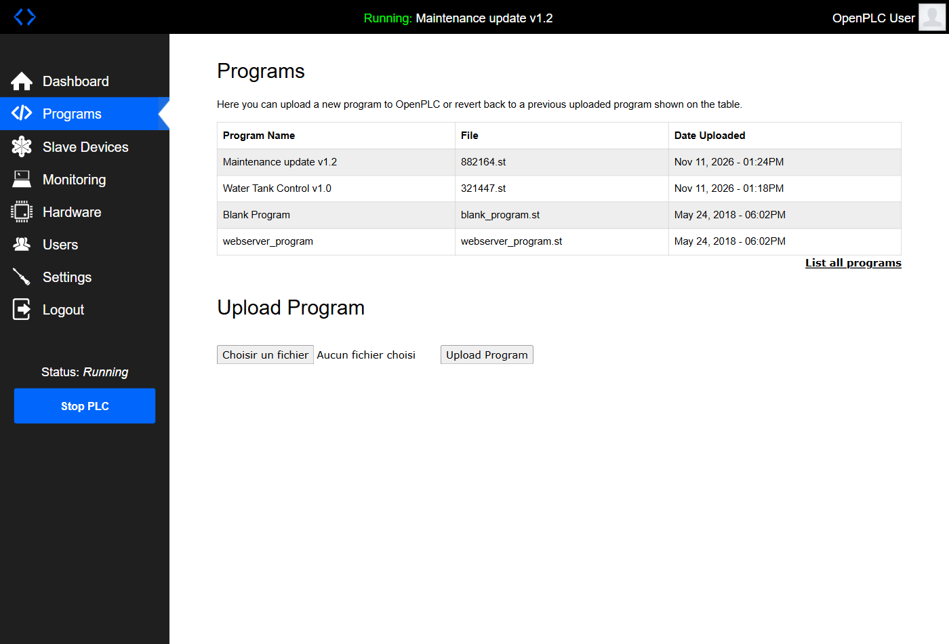
Fig. 6 — Programs page: the malicious program disguised as "Maintenance update v1.2".
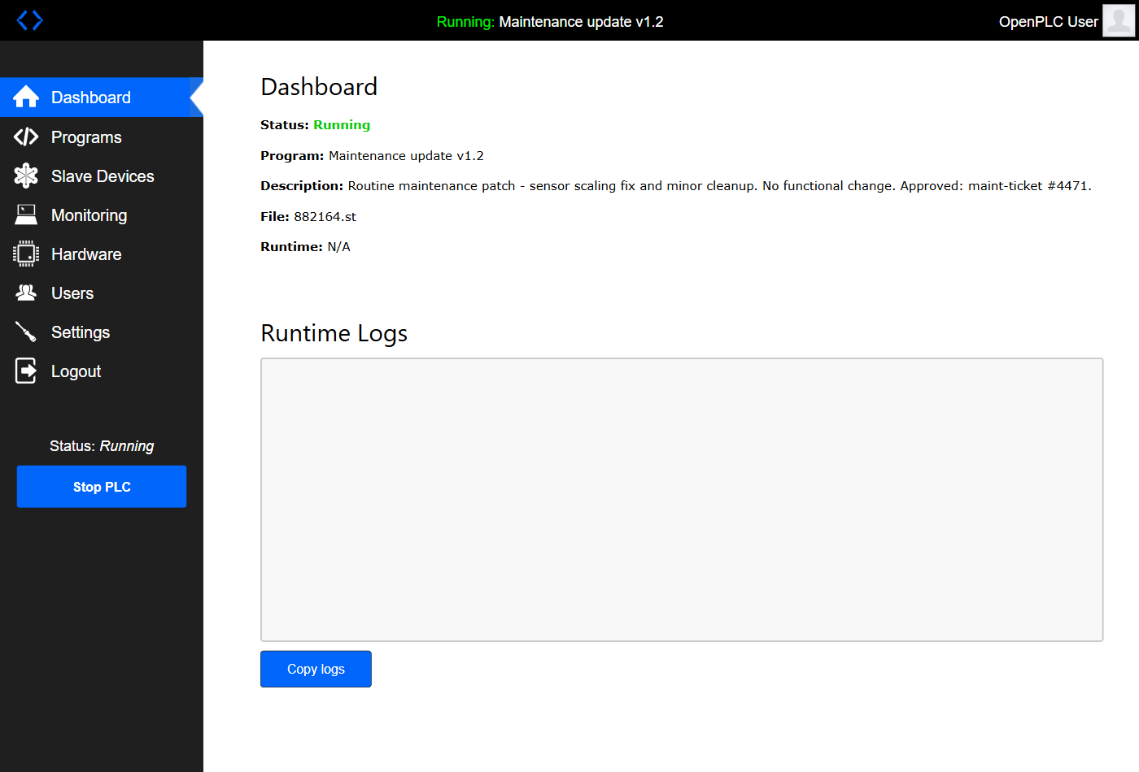
Fig. 7 — Dashboard: the PLC now runs the tampered program.
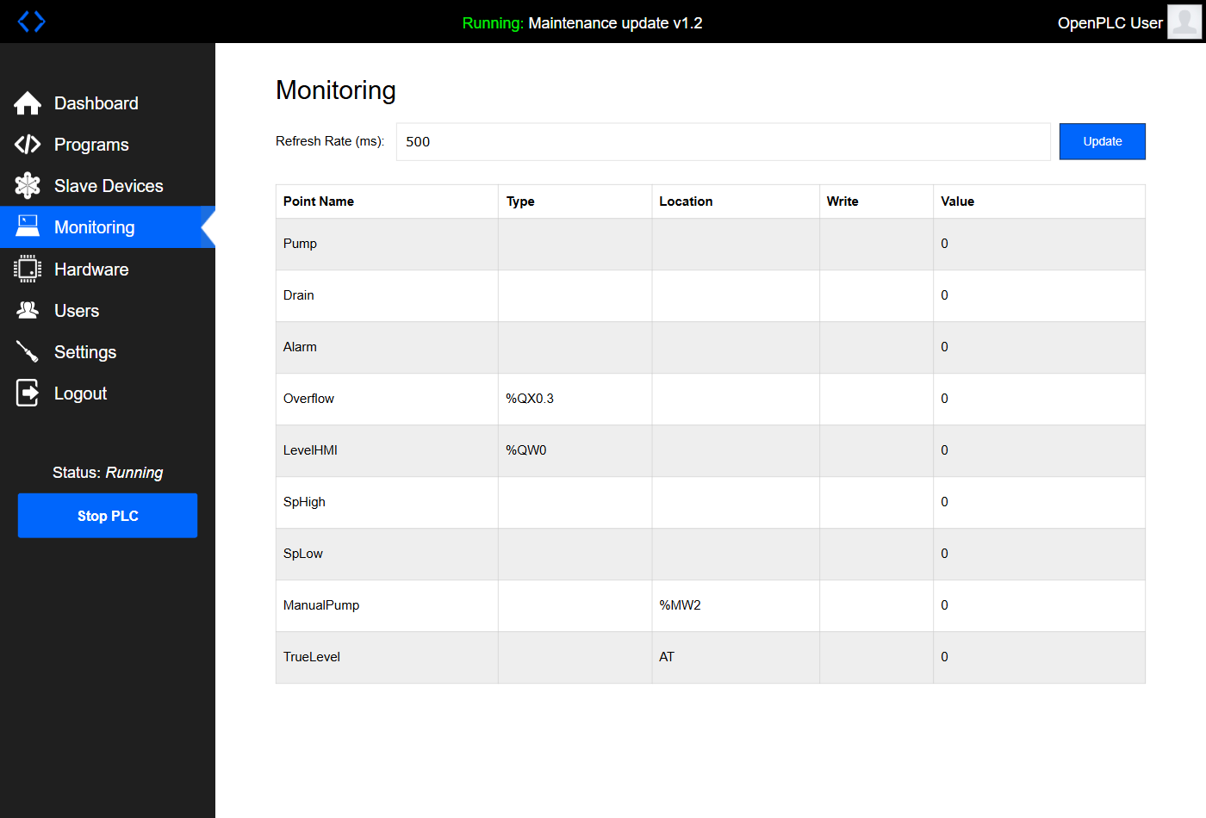
Fig. 8 — Monitoring under the tampered program: the process point list (live values travel over OpenPLC's internal debug channel). The spoofing itself is demonstrated by the live acquisition (§7) and Fig. 9.

6.4 The payload: 4 changed lines
The tampered program is identical to the legitimate one except for four lines:
Legitimate program | Tampered program
IF TrueLevel >= 950 THEN PumpCmd := FALSE; (safety) | (line removed -> the pump never stops)
IF TrueLevel >= 1000 THEN Overflow := TRUE; | Overflow := FALSE; (overflow hidden)
Alarm := (TrueLevel >= 950); | Alarm := FALSE; (alarm suppressed)
LevelHMI := TrueLevel; (truth) | LevelHMI := 470 + SpoofPhase; (spoofed)

7. Step 4 — Forensic acquisition
Evidence is collected in order of volatility (from most fragile to most stable): (1) live register state — including the hidden true level; (2) finalization of the pcap; (3) docker diff / logs / inspect; (4) copy of the SQLite database, the .st files and the compiled program; (5) export of the container filesystem; (6) historian; (7) SHA-256 + chain of custody; (8) making the evidence read-only.
evidence/acquisition/live_registers.json (live acquisition)
level_hmi (shown to operator) : 533
true_level (%MW10, real) : 1000
alarm : 0 overflow : 0 manual : 1 sp_high : 2000
=> displayed / real GAP : 467 units (direct proof of spoofing)

Chain of custody: 27 artifacts recorded in evidence/acquisition/chain_of_custody.csv, each hashed with SHA-256 (hashes.sha256) and frozen read-only after hashing.

8. Step 5 — Evidence analysis

8.1 Network — unauthorized Modbus writes
The pcap analysis extracts every Modbus transaction and flags writes (FC5/6/15/16) originating from an IP other than the HMI: these are the rogue commands (the direct proof of the manipulation).
UTC | Source | Function | IEC address | Value
2026-11-11T13:21:52.573Z | 172.28.0.66 | WriteSingleCoil | %QX0.0
2026-11-11T13:21:53.574Z | 172.28.0.66 | WriteSingleRegister | %MW0 | 2000
2026-11-11T13:21:54.574Z | 172.28.0.66 | WriteMultipleRegisters | %MW2 | 1
2026-11-11T13:24:59.800Z | 172.28.0.66 | WriteMultipleRegisters | %MW2 | 1
2026-11-11T13:24:59.801Z | 172.28.0.66 | WriteSingleRegister | %MW0 | 2000

Wireshark filter to reproduce: mbtcp && modbus.func_code in {5 6 15 16} && ip.src != 172.28.0.20

8.2 PLC — program comparison
The acquired SQLite database shows the tampered program stored as "Maintenance update v1.2" (latest upload date). The legitimate vs tampered diff (section 6.4) isolates the 4 sabotage lines. The baseline vs acquisition SHA-256 hashes prove which files changed.

8.3 Historian — what the operator saw vs reality
Headline figure: the level shown to the operator (blue) and the true level (red) overlap during normal operation, then DIVERGE sharply after the tampering — the red line overflows (1000) while the blue stays calm.
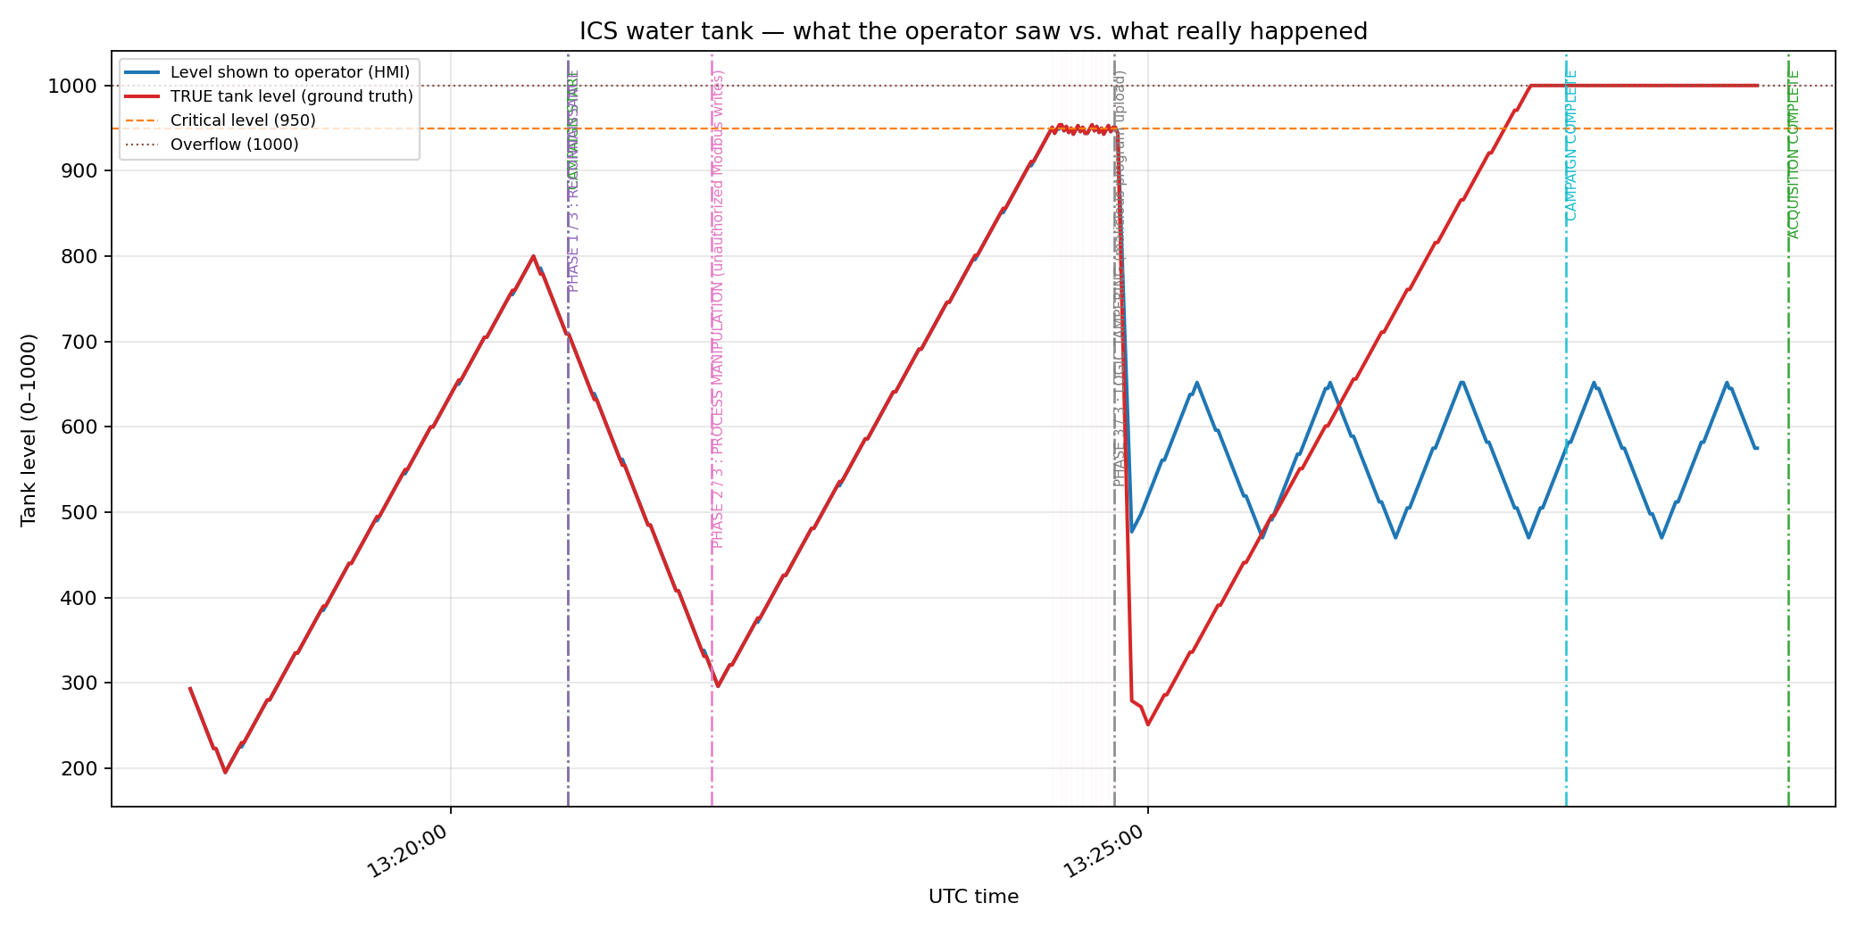
Fig. 9 — "What the operator saw" (blue) vs "what really happened" (red). Attack phases are marked.

8.4 Unified incident timeline
All sources (action log, pcap, OpenPLC database, container starts, historian anomalies) are merged into a single UTC-sorted timeline.
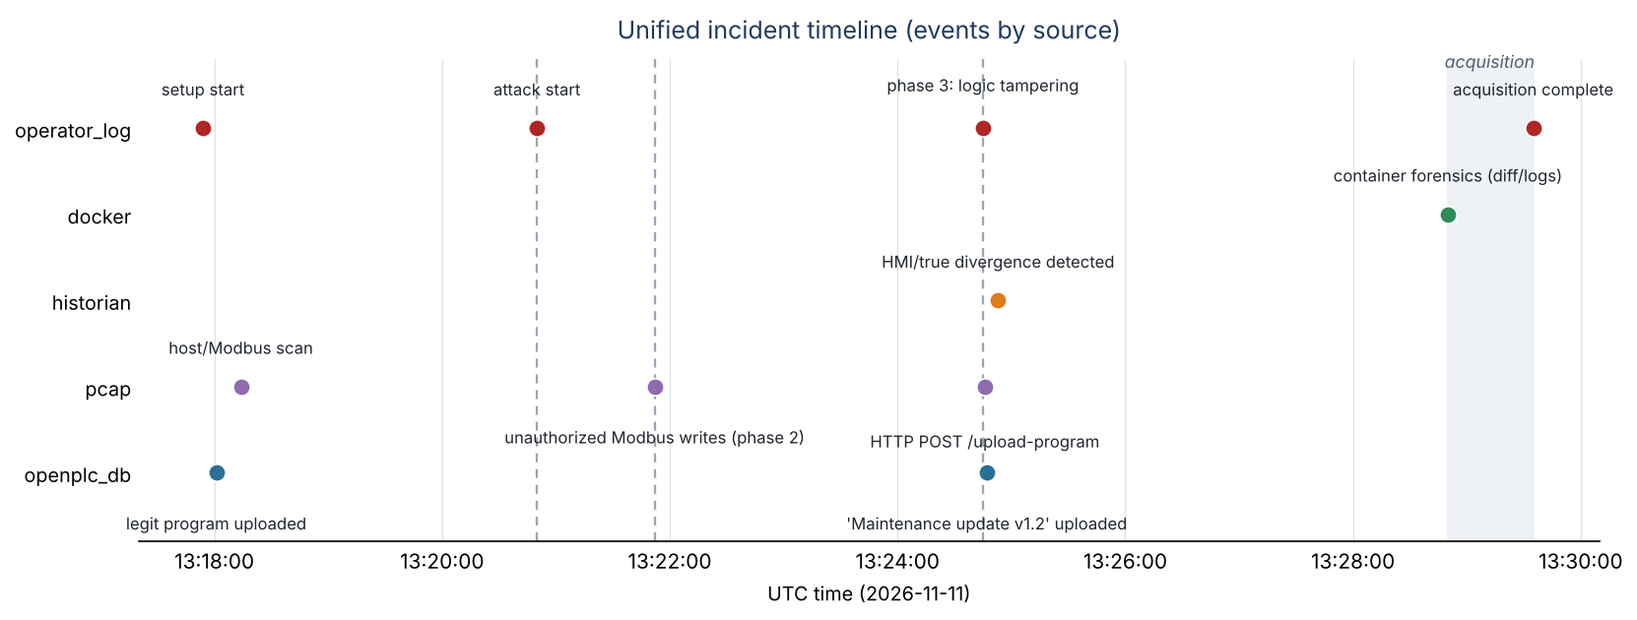
Fig. 10 — Unified timeline: events by source over time.

9. Conclusions and recommendations
- Modbus/TCP offers no authentication or integrity: segment the control network and restrict writes.
- The OpenPLC interface used default credentials: enforce strong credentials and restrict management-plane access.
- The PLC's software safety could be overwritten: provide an independent hardware safety layer (SIS).
- The operator relied solely on PLC-reported values: add independent instrumentation and anomaly detection (e.g. pump energized while the level looks steady).

10. Laboratory limitations
Soft PLC (no real hardware or firmware), simulated physics, single clock (no time-synchronization issues), and the graph's "true level" comes from a lab instrumentation probe a real investigator would not have (only the live acquisition snapshot). Details in docs/LIMITATIONS.md. Despite this, the forensic process demonstrated is faithful: ordered acquisition, hashing, chain of custody, network/PLC/historian analysis and a unified timeline.

